TRIBHUVAN UNIVERSITY
INSTITUTE OF ENGINEERING

Kathmandu Engineering College
Department of Computer Engineering



Minor Project Proposal
On
Stock Market Prediction
[Code No: CT 654]
By
Abhishek Man Shrestha - 078BCT009
Ayush Acharya - 078BCT022
Bishranta Regmi - 078BCT027
Dhiraj Sah - 078BCT030

Kathmandu, Nepal
2081

ABSTRACT
This project aims to create a stock market prediction system that combines historical dataset analysis with sentiment analysis from news articles and social media. By integrating machine learning algorithms, we seek to enhance the accuracy of forecasting future stock prices. Historical stock price data will be collected from reliable sources like NEPSE and NepseAlpha and sentiment data will be extracted using natural language processing techniques and algorithm like CNN. Through preprocessing and feature extraction, sentiment scores will be fused with historical data analysis to refine predictive models. Various machine learning algorithms, such as LSTM, CNNs, RNNs, will be explored for both dataset analysis and sentiment analysis. The project will conclude with the development of a user-friendly interface in the form of web app for visualizing prediction results and insights. Continuous evaluation and refinement of models will ensure their efficiency.
Keywords: stock, historical dataset, sentiment, analysis

TABLE OF CONTENTS

ABSTRACT i
TABLE OF CONTENTS ii
LIST OF FIGURES iv
LIST OF ABBREVIATIONS v
CHAPTER 1: INTRODUCTION 1
1.1 BACKGROUND THEORY 1
1.2 PROBLEM STATEMENT 2
1.3 OBJECTIVES 2
1.4 SCOPE AND APPLICATIONS 2
CHAPTER 2: LITERATURE REVIEW 3
2.1 EXISTING SYSTEMS 4
2.1.1 QuantConnect 4
2.1.2 MetaTrader5 4
2.1.3 AlphaSense 5
2.2 LIMITATIONS OF PREVIOUS SYSTEMS 5
2.3 SOLUTIONS PROPOSED BY OUR SYSTEM 5
CHAPTER 3: METHODOLOGY 6
3.1 PROCESS MODEL 6
3.1.1 INCREMENTAL MODEL 6
3.2 BLOCK DIAGRAM 8
3.3 ALGORITHMS 9
3.3.1 Recurrent Neural Network (RNNs) 10
3.3.2 Convolution Neural Networks (CNNs) 10
3.3.3 Long Short-Term Memory (LSTM) 11
3.4 FLOWCHART 12
3.5 TOOLS TO BE USED 13
3.5.1 Python 13
3.5.2 HTML/CSS 13
3.5.3 Flask 13
3.5.4 Stack Overflow 13
3.5.5 Github 13
3.5.6 ChatGPT 13

CHAPTER 4: EPILOGUE 14
4.1 EXPECTED OUTPUT 14
4.2 GANTT CHART 14
REFERENCES 15
BIBLIOGRAPHY 16

LIST OF FIGURES

Figure 1: Iterative Process Model .................................................................................6
Figure 2: Block Diagram of the Proposed System .......................................................8
Figure 3: Recurrent Neural Network...........................................................................10
Figure 4: Convolution Neural Network.......................................................................10
Figure 5: Long Short-Term Memory...........................................................................11
Figure 6: Flowchart......................................................................................................12
Figure 7: Gantt Chart...................................................................................................14

LIST OF ABBREVIATIONS

ANN Artificial Neural Network
BGRU Bidirectional Gated Recurrent Unit
CNN Convolution Neural Network
CSS Cascading Style Sheets
HTML HyperText Markup Language
HTTP HyperText Transfer Protocol
LSTM Long Short-Term Memory
RNN Recurrent Neural Network
SVM Support Vector Machine

CHAPTER 1: INTRODUCTION

1.1 BACKGROUND THEORY
The stock market is a system where people can buy and sell shares of publicly traded companies. Companies issue shares of stock to the public to raise funds for their operations and growth. The stock market operates on the principle of supply and demand. When demand for a company's stock is high, its share price rises, and vice versa. Investors purchase these shares because they believe the company will succeed and grow over time, increasing the value of their investment. If the company performs well, the stock price usually goes up, allowing investors to sell their shares at a higher price and make a profit.
The Nepal Stock Exchange (NEPSE) is the main stock exchange of Nepal. NEPSE opened its trading floor on 13 January 1994. It was established to provide a marketplace for the trading of securities in Nepal. The exchange facilitates transactions for both individual and institutional investors and plays a vital role in the economic development of Nepal by enabling companies to access public funds for expansion and growth.
Stock market prediction involves forecasting the future value of a company's stock, which is crucial for economic growth. By studying patterns in market data, we can predict when to buy stocks and potentially earn profits. This prediction relies on understanding supply and demand. By analyzing large amounts of market data, we can find patterns that give us a good chance of making accurate predictions. Stock market prediction consists of statistical analysis, machine learning, and sentiment analysis to forecast future stock prices using historical data and market sentiment. Integrating these methods and using machine learning helps to develop predictive models offering valuable insights of the market.

1.2 PROBLEM STATEMENT
The stock market is vast and unpredictable, with significant fluctuations making it challenging to anticipate whether prices will rise or fall the next day. Investing in stocks can result substantial profits or result in significant losses, making it a scary task for many. Manual methods of predicting future market trends are tedious and often inaccurate, especially when the financial markets are influenced by factors like politics, economics, and investor psychology.

1.3 OBJECTIVES
This project was created with the purpose to fulfill the following objectives:
- To analyze historical trading data (date, closing price, etc.) and sentimental data (news headlines, articles, posts, etc.) to understand market trends.
- To predict future price using the information from analyzed data implementing machine learning algorithms like RNN, CNN and LSTM.

1.4 SCOPE AND APPLICATIONS
The applications of this project are as follows:
- To bridge communication between financial investors and industries as investors can find right companies for investments and companies can find investors for their growth
- To assist the investors and people to make sensible decisions for profitable investments through analysis of historical trading data.

CHAPTER 2: LITERATURE REVIEW

A number of researchers have explored different methods to detect forged and AI-generated images, reflecting the growing importance of image authenticity in fields such as forensic science, journalism, and social media.
One comprehensive study by Preeti Sharma, Manoj Kumar, and Hitesh Sharma in 2022 evaluates both traditional and advanced deep learning approaches for image tamper detection. Their research highlights how easily available editing tools can alter images, making it difficult to distinguish between authentic and manipulated content. They discuss active, passive, and deep learning-based methods—including those using generative adversarial networks (GANs)—and emphasize the need for standardized datasets and evaluation criteria to improve detection accuracy. The study concludes that while deep learning techniques show great promise, challenges remain in generalizing across different types of forgeries and photo-realistic manipulations [1].
Another recent study by Clifa Mascarenhas and Nadine Dias in 2024 focuses on the use of deep learning for detecting digital image forgery. Their project uses a curated dataset of both authentic and manipulated images, applying lightweight deep learning architectures and transfer learning from pre-trained models to achieve reliable detection. The authors highlight the effectiveness of convolutional neural networks (CNNs) in learning complex features from large datasets, which helps the model distinguish between genuine and forged images with high accuracy. Their work demonstrates that deep learning methods can enhance image forensics and help protect the credibility of visual content in the digital age [2].
In the context of AI-generated image detection, a 2024 study titled "Performance Comparison and Visualization of AI-Generated-Image Detection Methods" compares several detection approaches using different types of generative models, including GANs, diffusion models, and transformers. The research finds that artifact-feature-based detection works well for GAN-generated images, while image-encoder-feature-based methods are more effective for diffusion and transformer-generated images. The study also uses visualization techniques like Grad-CAM and t-SNE to show which parts of the image the model uses for detection. The results highlight that detection accuracy varies depending on the type of AI-generated image and that some methods are more robust to image compression than others [3].
For image tampering detection, Ramesh Gorle’s 2024 paper introduces a novel approach combining Error Level Analysis (ELA) with a CNN. Traditional forensic methods like ELA can struggle with subtle manipulations, but by preprocessing images with ELA and then using a CNN for classification, the proposed framework achieves a detection accuracy of 96.21% on the CASIA v2.0 dataset. This method outperforms established deep learning models such as VGG16, VGG19, and ResNet101, showing that combining traditional and deep learning techniques can provide a robust solution for detecting digital image manipulation [4].
A further study by Emad Ul Haq Qazi and colleagues in 2024 proposes a transfer learning-based deep learning technique for image forgery detection. Their approach uses pre-trained weights to reduce training time and resource requirements, and it achieves an impressive accuracy of 99.92% on benchmark datasets such as BOW and BOSSBase. This demonstrates that leveraging existing deep learning models through transfer learning can significantly improve the efficiency and effectiveness of image authenticity verification [5].
Lastly, a review by Parita Mer, Reshma Sunil, and Anjali Diwan in 2023 provides a broad survey of image forgery detection techniques, from traditional handcrafted feature methods to modern deep learning approaches. The review discusses the strengths and limitations of each method, the types of forgeries they can detect, and the datasets used for evaluation. It highlights the evolution of forgery detection from rule-based algorithms to data-driven deep learning models, which have become the standard for robust and automated detection in recent years [6].

2.1 EXISTING SYSTEMS
2.1.1 FotoForensics
FotoForensics is a widely used online tool that analyzes images for signs of manipulation using error level analysis (ELA) and examines EXIF metadata to detect inconsistencies. Users upload an image, and the system highlights edited regions, providing clues about potential tampering and metadata anomalies.
2.1.2 Ghiro
Ghiro is an open-source digital forensics tool that performs deep analysis of images, including metadata inspection, ELA, and color map checks. It is designed for technical users and offers customizable forensic analysis for detecting various forms of image manipulation.
2.1.3 Pixelator v2
Developed by York St John University, Pixelator v2 is designed to detect subtle alterations in images, even as small as a single pixel. The tool combines advanced image veracity techniques and is available for free, targeting cybersecurity professionals and analysts.
2.1.4 AI-FORGERYGUARD
AI-FORGERYGUARD is a research-based system that uses Convolutional Neural Networks (CNNs) to detect image forgeries automatically. The system processes images through interconnected modules, generates reports on detected manipulations, and is designed to reduce reliance on human intervention.

2.2 LIMITATIONS OF PREVIOUS SYSTEMS
- Limited Detection Scope: Many existing tools focus only on detecting traditional forgeries (e.g., ELA-based, metadata-based) and do not effectively identify AI-generated images, which are becoming increasingly common.
- Accuracy and Generalization: Some systems struggle to maintain high accuracy across diverse and complex datasets, especially when dealing with new types of image manipulation or highly realistic AI-generated content.
- Technical Barriers: Tools like Ghiro and JPEGsnoop require technical expertise to install and use, making them less accessible to non-technical users.
- Lack of Comprehensive Reporting: Most existing systems do not provide detailed, user-friendly reports that explain detection results, confidence levels, and the basis for their conclusions.
- Adaptability: Existing systems often have difficulties adapting to rapidly evolving AI image generation techniques and may need frequent updates to stay effective.

2.3 SOLUTIONS PROPOSED BY OUR SYSTEM
- Dual Detection Capability: Our system will detect both traditional image forgeries (such as copy-move, splicing) and AI-generated images, providing a more comprehensive solution compared to existing tools that often focus on only one type.
- Comprehensive Reporting: We plan to generate detailed reports for users, including confidence scores, visualizations of manipulated regions, and clear explanations of why an image was flagged as forged or AI-generated.
- User-Friendly Interface: Our system will offer a simple, web-based interface that requires no technical expertise, making it accessible to a wide range of users.
- Continuous Learning and Adaptability: By leveraging advanced machine learning models and regularly updating our training datasets, our system aims to adapt to new types of image manipulation and AI generation techniques, improving detection accuracy over time.
- Use of Multiple Techniques: We will various suitable deep learning-based detection techniques to maximize accuracy and robustness across various image types and manipulation methods.

CHAPTER 3: METHODOLOGY

3.1 PROCESS MODEL

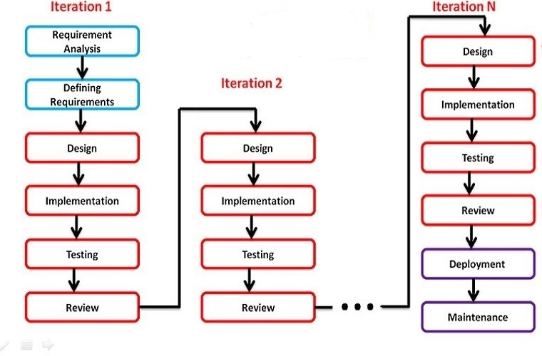
3.1.1 ITERATIVE MODEL
Figure 1: Iterative Process Model

In the iterative model, the process starts with a simple implementation of the software requirements and iteratively enhances the versions until the complete system is implemented and ready to be deployed.
The various phases of iterative model are as follows:
1. Requirement analysis: In the first phase, the identification of the key requirements for the stock prediction system, such as historical data analysis, sentiment analysis, and the integration of both is done. To develop the software under the incremental model, this phase performs a crucial role.
2. Design: In this phase, design of the features to be used in the model, such as moving averages from historical data and sentiment scores from text data are done along with simple LSTM model for time-series prediction using historical data and a basic sentiment analysis module to process textual data.
3. Implementation: Implementation phase enables the coding phase of the development system. It involves the final coding that implements a basic LSTM model for predicting stock prices based on historical data and integrate a sentiment analysis module using libraries like TextBlob or NLTK.
4. Testing: The testing phase checks the performance of each existing function, tests the LSTM model's accuracy in predicting stock prices and verifies that the sentiment scores are correctly influencing the predictions.
5. Review: After testing the model's performance, identifying areas for improvement, such as enhancing sentiment analysis or refining the LSTM model is done. Planning to integrate more advanced techniques or additional data sources in the next iteration is done if necessary.
6. Deployment: After completing all the phases, software is deployed to its work environment where users can interact with it and provide further feedback if any improvement or correction is required.
7. Maintenance: In the maintenance phase, after deployment of the software in the working environment there may be some bugs, some errors or new updates are required. Maintenance involves debugging and addition of new options.
Advantages of iterative process model:
- Repeated cycles of development allow for continuous improvement and refinement of the software.
- Early prototypes provide a possible product that user can review and provide feedback on.
- Frequent testing and evaluation throughout each iteration help identify and fix defects early.
- Flexibility in adjusting changes is increased, as each iteration provides an opportunity to adjust requirements based on user feedback and evolving needs.

3.2 BLOCK DIAGRAM
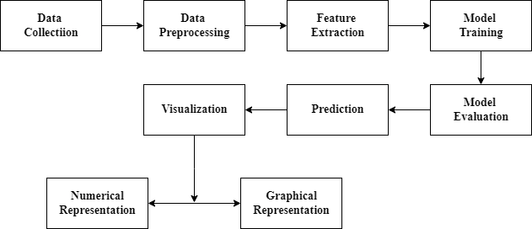

Figure 2: Block Diagram of the Proposed System

This block diagram outlines the main components of the stock prediction system that are explained below:
1. Data Collection: This step includes gathering of historical stock price data of companies from credible sources like NEPSE, Nepse Alpha, ShareSansar, etc. and textual data from various sources like news websites, social media, and financial forums related to specific companies by scrapping the data available for general public.
2. Data Preprocessing: This involves cleansing and normalization of historical stock data like handling missing values and scaling, and creating additional features like moving averages. This also include tokenization, stop-word removal of textual data that prepares the text for sentiment analysis by converting it into a format suitable for machine learning algorithms.
3. Feature Extraction: Extraction of relevant features and technical indicators from the preprocessed data is done in this step. The features may include moving averages, Relative Strength Index (RSI), sentiment scores, sentiment polarity and sentiment subjectivity.
4. Model Training: LSTM (Long Short-Term Memory) neural network is employed for time-series analysis of historical stock data and utilization of CNN (Convolutional Neural Network) algorithm is done to analyze textual data and extract sentiment-related features. The models are properly trained using the collected datasets to provide output as accurate as possible.
5. Model Integration: The extracted features from both historical and textual data are combined into a single feature set. This integrated feature set provides comprehensive input for the predictive models, capturing both market trends and sentiment factors. This can be achieved by libraries like TextBlob or NLTK.
5. Model Evaluation: Evaluation of the LSTM model's accuracy in predicting stock prices based on given data is done and verification is done if sentiment scores are correctly influencing the predictions or not.
6. Prediction: The integrated model generates predictions for future stock prices based on the combined feature set. These predictions provide valuable insights into potential market movements and assist investors in making informed decisions.
7. Visualization: The predicted stock prices, along with relevant analytics and insights, are visualized and presented in user-friendly formats in a web application such as charts and graphs. These visualizations can help in interpreting the model predictions and understanding market trends.

3.3 ALGORITHMS

3.3.1 Recurrent Neural Network (RNNs)
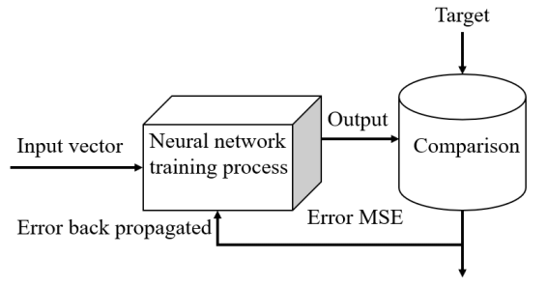
Recurrent Neural Networks (RNNs) are a type of neural network that are designed to process sequential data. They can analyze data with a temporal dimension, such as time series, speech, and text. RNNs can do this by using a hidden state passed from one timestep to the next. The hidden state is updated at each timestep based on the input and the previous hidden state.

Figure 3: Recurrent Neural Network

3.3.2 Convolutional Neural Networks (CNNs)
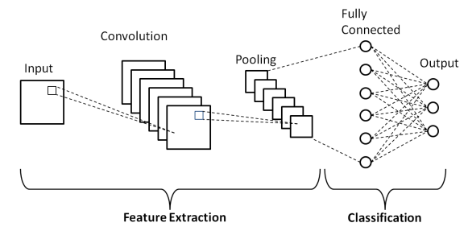
Convolutional Neural Networks (CNNs) are powerful deep learning models primarily used for image and text data analysis. In the context of stock market prediction, CNNs excel at sentiment analysis by extracting meaningful patterns from textual data such as news articles and social media posts. By identifying sentiments and trends, CNNs enhance the overall predictive accuracy when combined with time-series models like LSTM.

Figure 4: Convolution Neural Network

3.3.3 Long Short-Term Memory (LSTM)
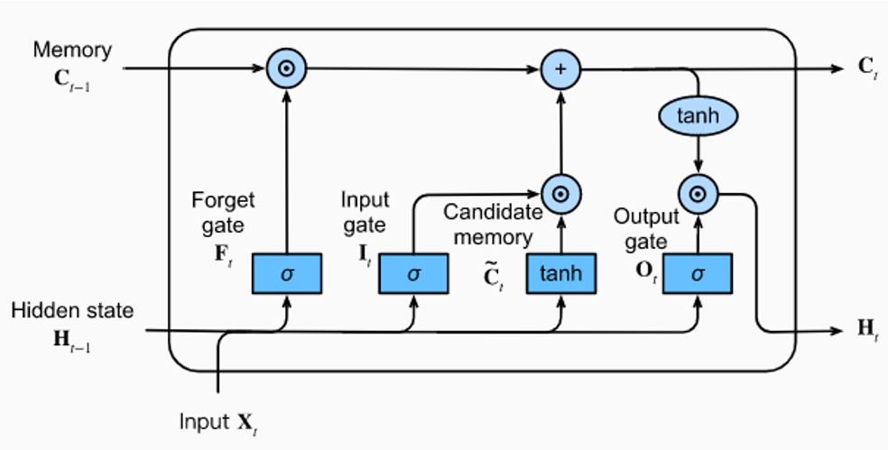
LSTMs Long Short-Term Memory is a type of RNNs that can detain long-term dependencies in sequential data. They use memory cell and gates to control the flow of information, allowing them to selectively retain or discard information as needed and thus avoid the vanishing gradient problem that plagues traditional RNNs. LSTMs are widely used in applications such as natural language processing, speech recognition, and time series forecasting.

Figure 5: Long Short-Term Memory

There are three types of gates in an LSTM:
Input gate: It decides which information to store in the memory cell. It is trained to open when the input is important and close when it is not.
Forget gate: It decides which information to discard from the memory cell. It is trained to open when the information is no longer important and close when it is.
Output gate: It is responsible for deciding which information to use for the output of LSTM. It is trained to open when the information is important and close when it is not.
The gates in an LSTM are trained to open and close based on the input and the previous hidden state. This allows the LSTM to selectively retain or discard information, making it more effective at capturing long-term dependencies.

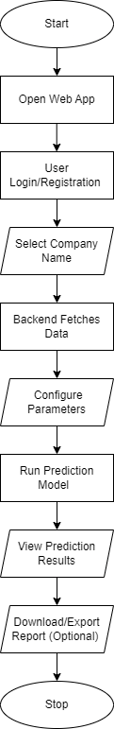
3.4 FLOWCHART

Figure 6: Flowchart

3.5 TOOLS TO BE USED

Python
Python is used for backend development, data preprocessing, and machine learning model implementation. Python libraries like NumPy, Pandas facilitate data analysis, machine learning tasks, and natural language processing.

HTML/CSS
HTML structures the content of web pages, while CSS styles and formats their appearance. HTML and CSS are employed for frontend development, creating the user interface for displaying prediction results.

Flask
Flask serves as the backend framework. Flask integrates the frontend of web application with the backend of prediction model done in python, enabling the creation of dynamic interface for users to interact.

Stack Overflow
Stack Overflow serves as a valuable resource for troubleshooting technical issues and seeking solutions to coding challenges. Developers can leverage Stack Overflow to find answers, ask questions, and access a vast repository of knowledge on relevant topics.

Github
GitHub hosts the project repository, facilitating version control, collaboration, and code management. Developers can use GitHub to share code, collaborate with team members, and contribute to open-source projects relevant to stock market prediction.

ChatGPT
ChatGPT provides assistance and guidance on project-related topics through natural language conversations. Developers can interact with ChatGPT to brainstorm ideas, seek advice, and access resources for refining their project strategy and implementation.

CHAPTER 4: EPILOGUE

4.1 EXPECTED OUTPUT
- The project will deliver a model capable of predicting stock prices with high accuracy for a range of stocks, based on the integration of historical data analysis and sentiment analysis. This includes short to medium-term forecasts that investors can use to make informed decisions.
- The system will generate detailed analytical reports that combine insights from historical trends, technical indicators, and sentiment analysis from news and social media. This will provide investors with a view of market conditions and potential future movements.

4.2 GANTT CHART

Tasks | JUN | JUL | AUG | SEP | OCT | NOV | DEC | JAN | FEB | MAR
Documentation
Planning
Analysis
Design
Implementation
Testing

Figure 7: Gantt Chart

REFERENCES

- Sharma, Preeti, Manoj Kumar, and Hitesh Sharma. "Comprehensive analyses of image forgery detection methods from traditional to deep learning approaches: an evaluation." Multimed Tools Appl 82, 18117–18150 (2022). doi: 10.1007/s11042-022-13808-w.
- Mascarenhas, Clifa, and Nadine Dias. "Comprehensive Analysis of Deep Learning Approach for detecting Forgery in Digital Images." International Research Journal of Engineering and Technology (IRJET) 11(5): 619-624, May 2024.
- "Performance Comparison and Visualization of AI-Generated-Image Detection Methods." 2024. Available at: scribd.com/document/794363570.
- Gorle, Ramesh. "Enhanced Image Tampering Detection using Error Level Analysis and CNN." Engineering, Technology & Applied Science Research 15(2), 2025.
- Qazi, Emad Ul Haq, et al. "Deep Learning-Based Digital Image Forgery Detection Using Transfer Learning." Intelligent Automation & Soft Computing 38(3), 225-240, 2024. doi: 10.32604/iasc.2023.041181.
- Mer, Parita, Reshma Sunil, and Anjali Diwan. "From Traditional to Deep: A Survey of Image Forgery Detection Techniques." 2023 IEEE 3rd Applied Signal Processing Conference (ASPCON), 103-108, 2023.

BIBLIOGRAPHY

- https://www.simplilearn.com/tutorials/artificial-intelligence-tutorial/lstm
- https://www ijcrt.org/papers/IJCRT2307700.pdf
- https://ieeexplore.ieee.org/abstract/document/10142902
- https://www.youtube.com/watch?v=b61DPVFX03I
- http://conference.ioe.edu.np/publications/ioegc11/ioegc-11-004-11005.pdf
- https://www.geeksforgeeks.org/convolutional-neural-network-cnn-in-machine-learning

